AWS ADVANCE BATCH 1 ASSIGNMENT DAY 15 AND 16:

Question 1:
Working with Lambda
Step1: Create two s3 buckets with the name
sourcebucket arn:aws:s3:::mysourcebucket0812
destinationbucket arn:aws:s3:::mydestinationbucket0812:
SS1: s3 console with two buckets
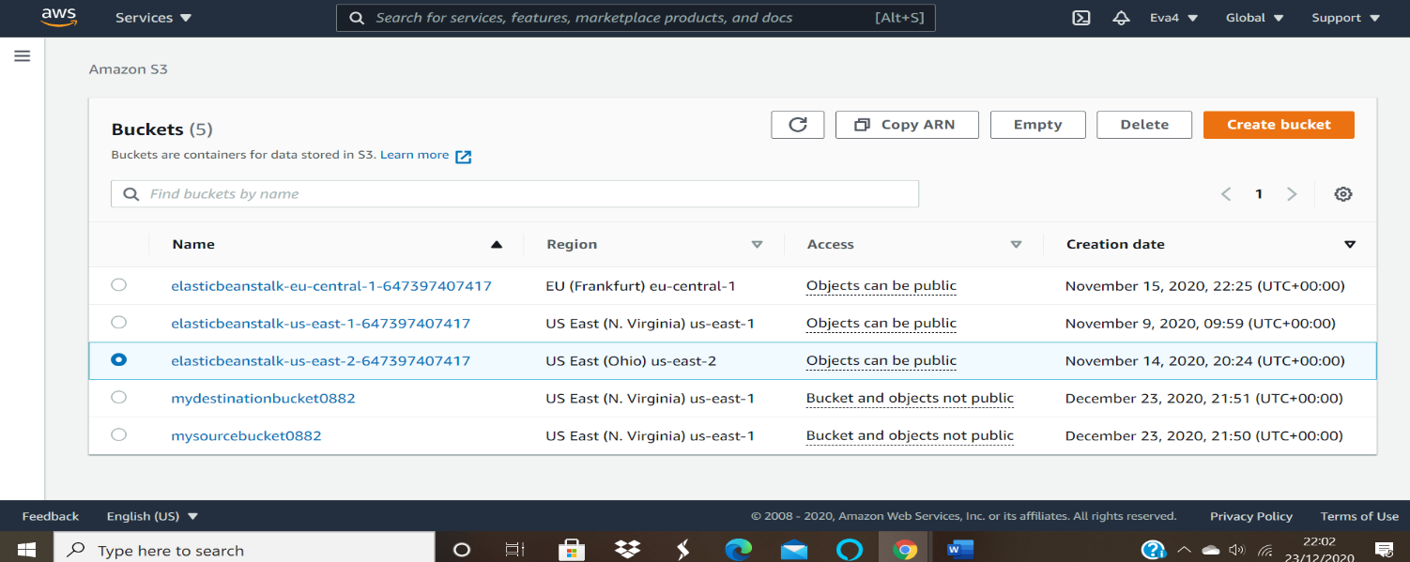
Sourcebucket:
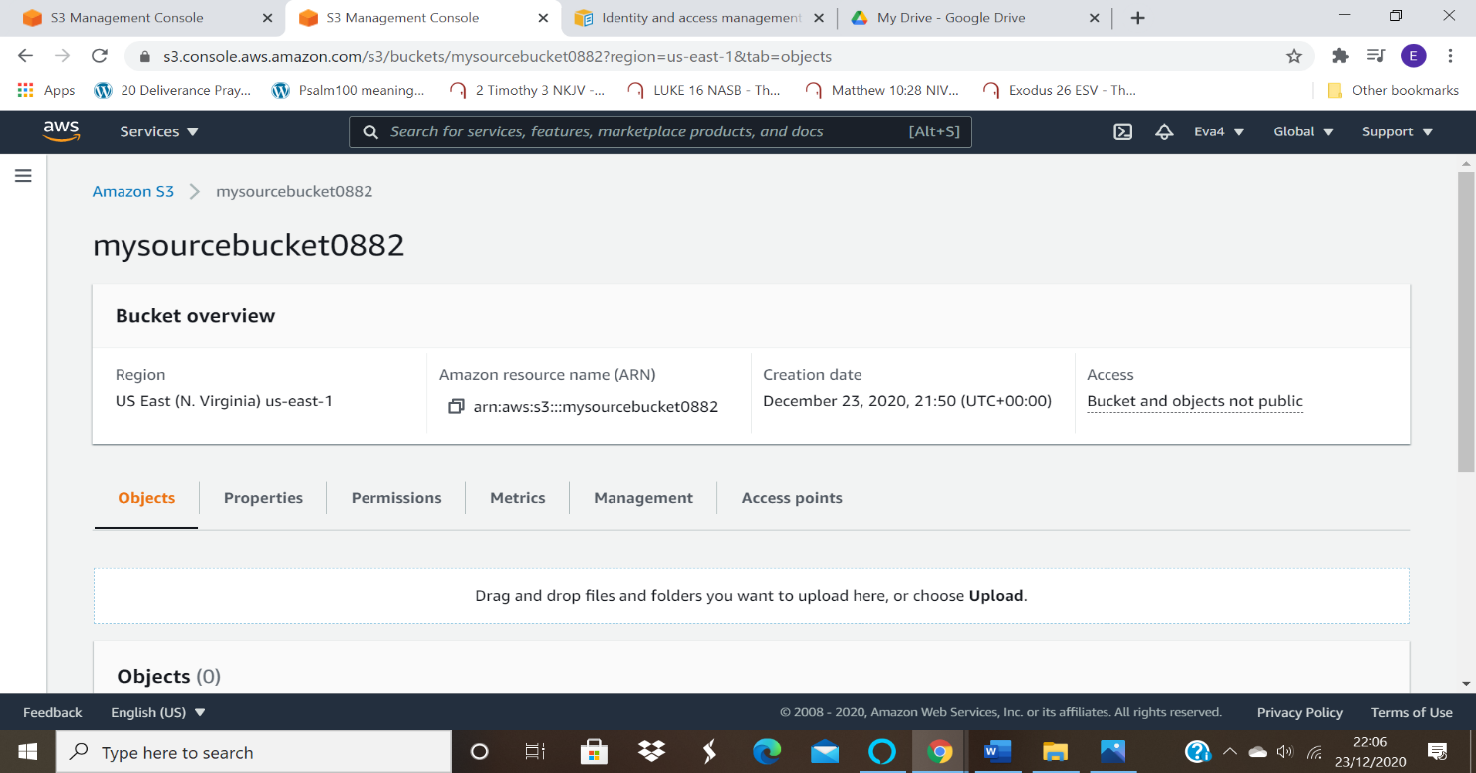
Destinationbucket:
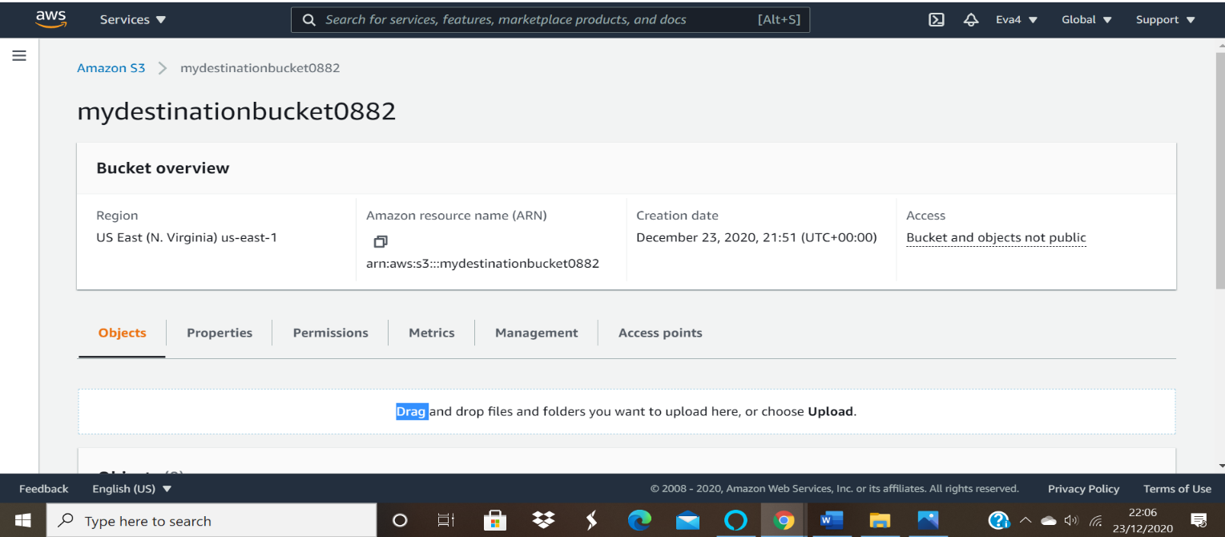

Step2: Create a policy with limited Read-write permissions using a JSON script
ss2: json script in place
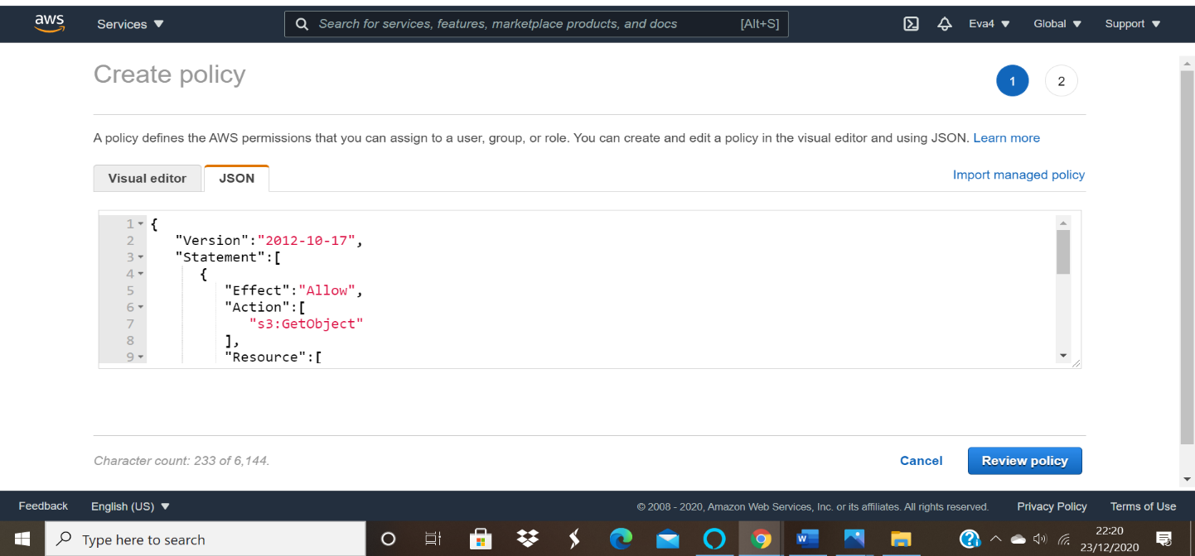
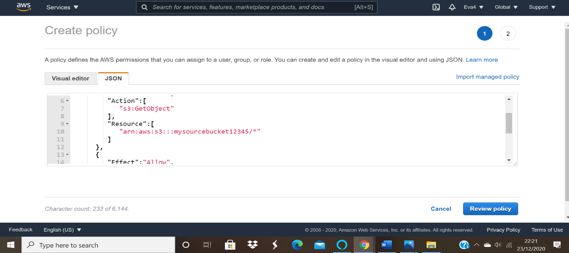

Replaced sourcebucket:
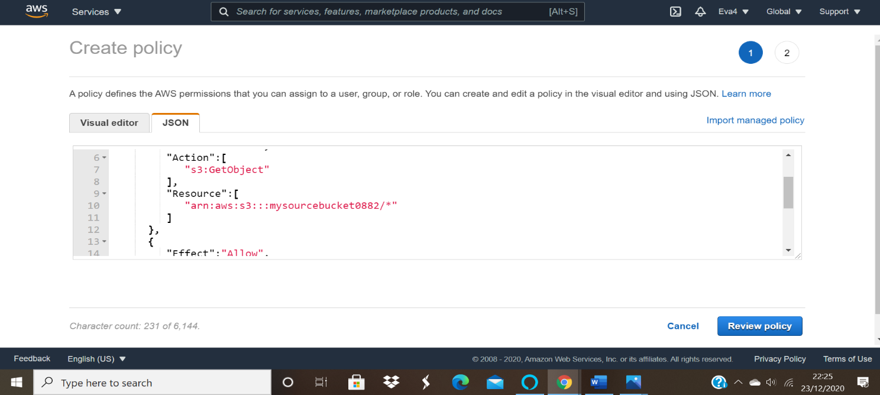

Replaced destinationbucket:
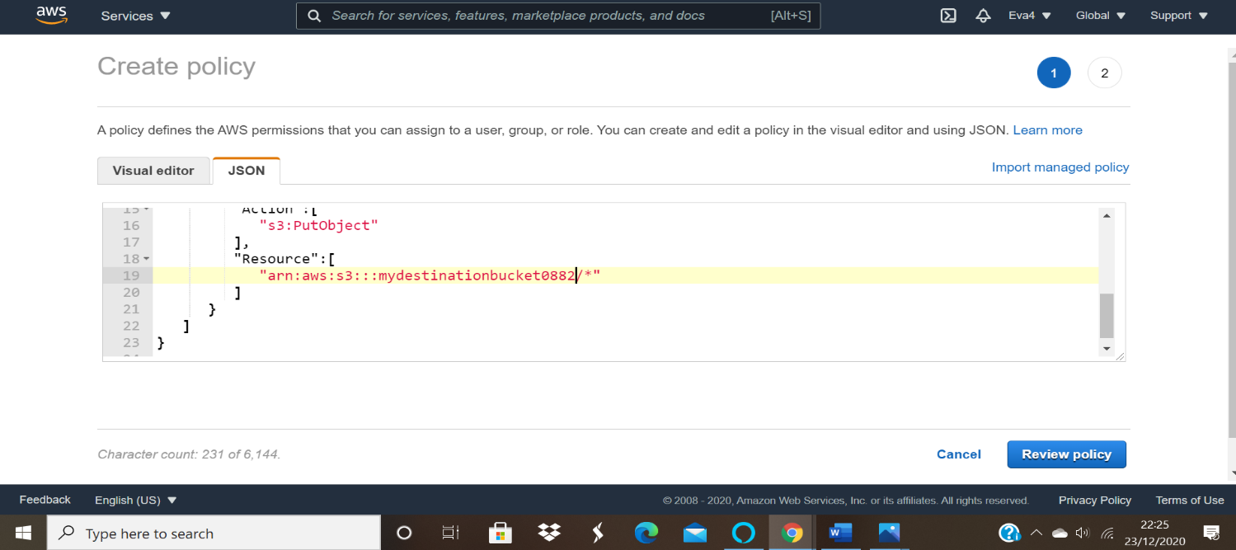
ss3: policy console with your policy filtered:
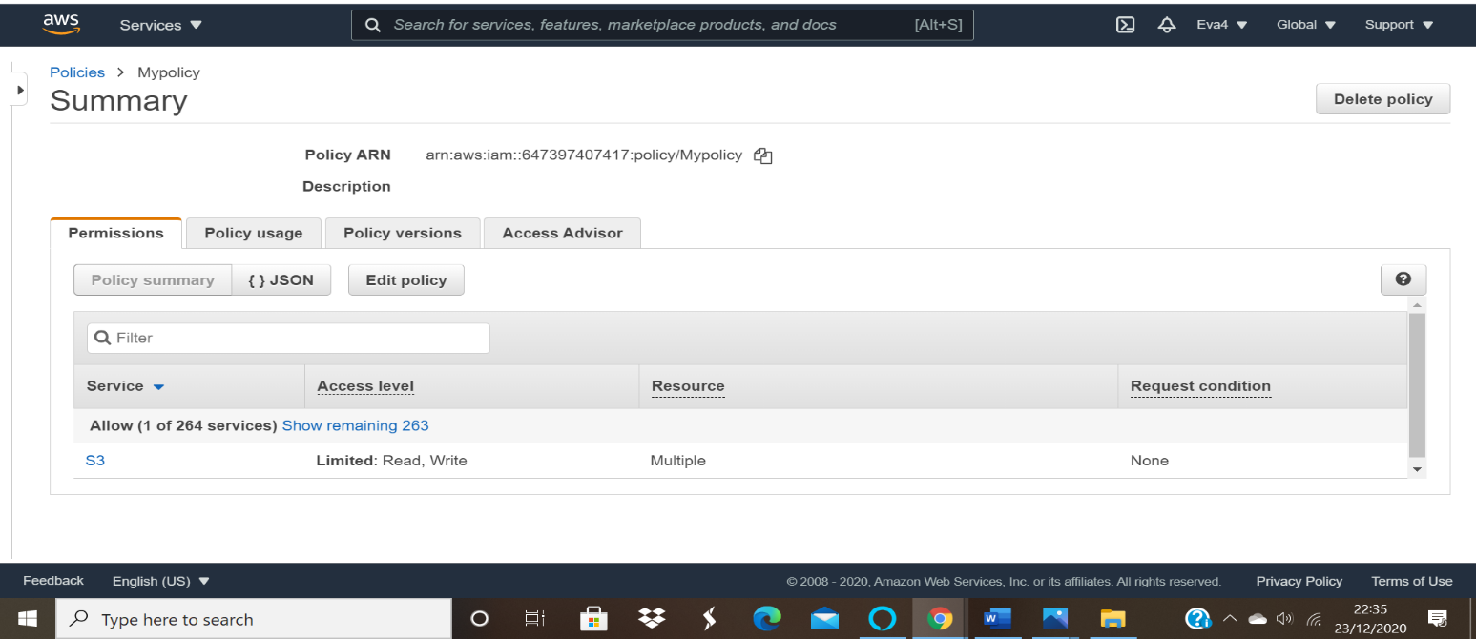

Step3: Create a role and attach the policy that was created in the previous step.
ss4: Role console showing details of the role
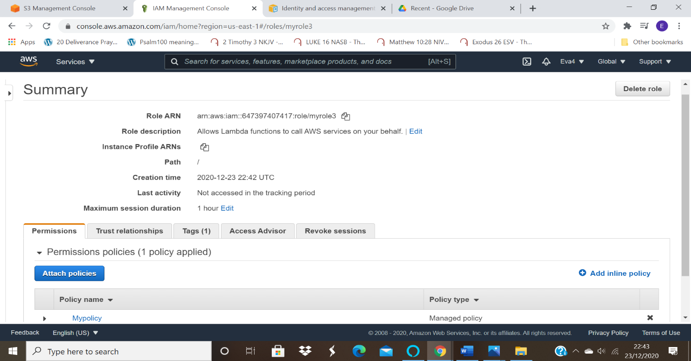

Step4: Create a Lambda function
ss5: Lambda functions dashboard
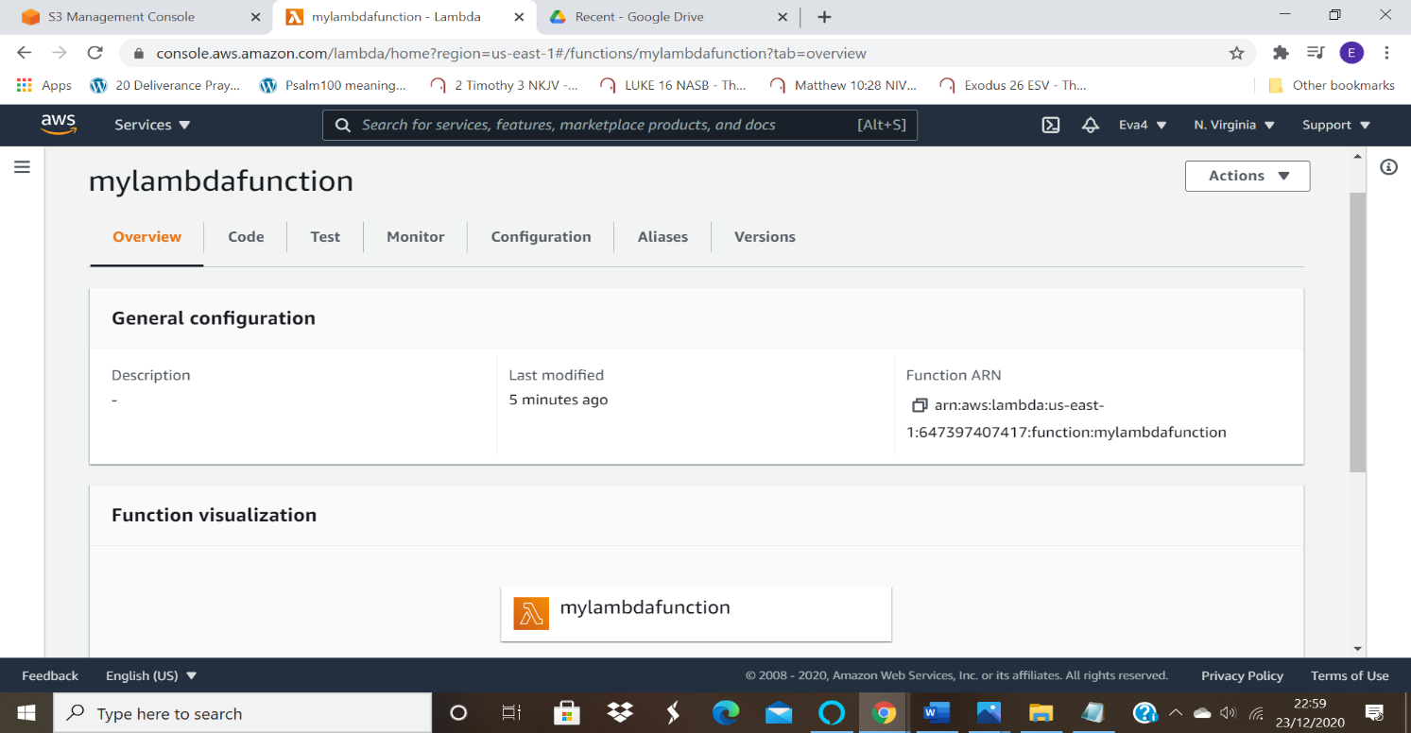

ss6:js file edited

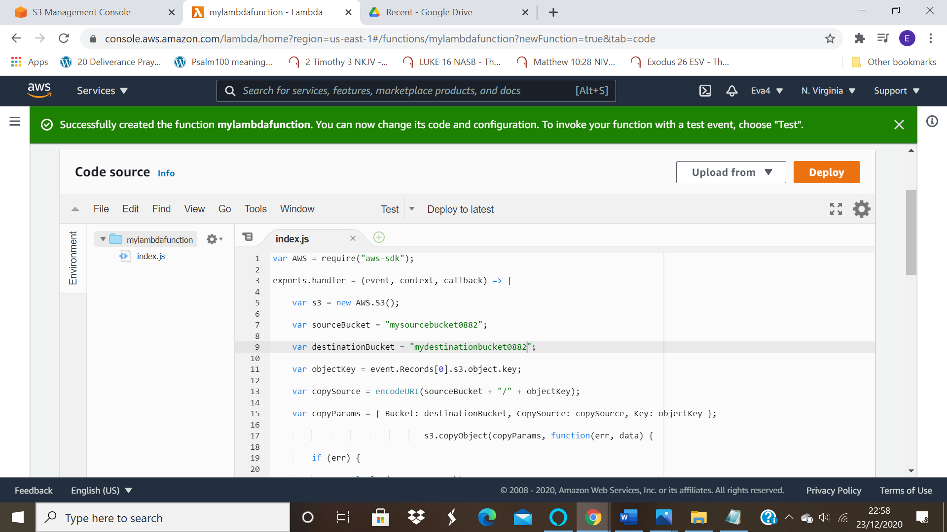
ss7: Adding trigger-s3, bucket name, confirmation for having separate buckets
To add trigger click on add trigger on the configuration page
Select the trigger in this case its s3:
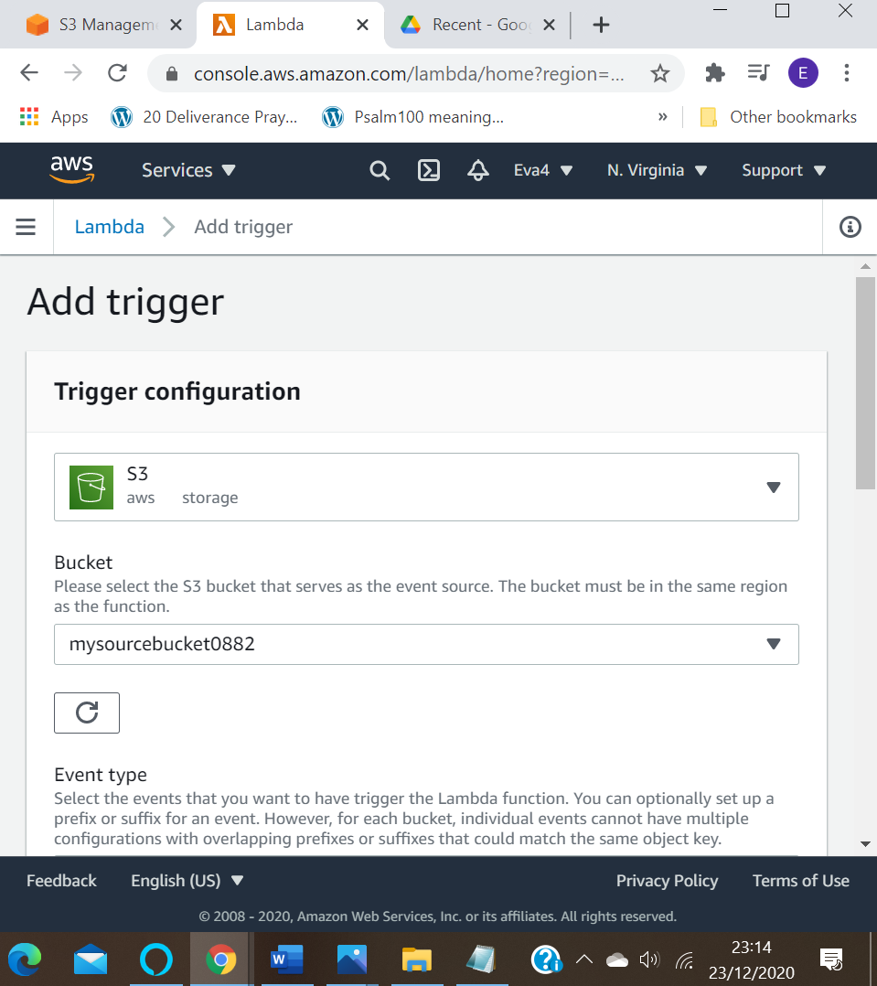

Step5: Adding triggers to the lambda function.
Picture for the added trigger.
ss8: Lambda configuration page with trigger added
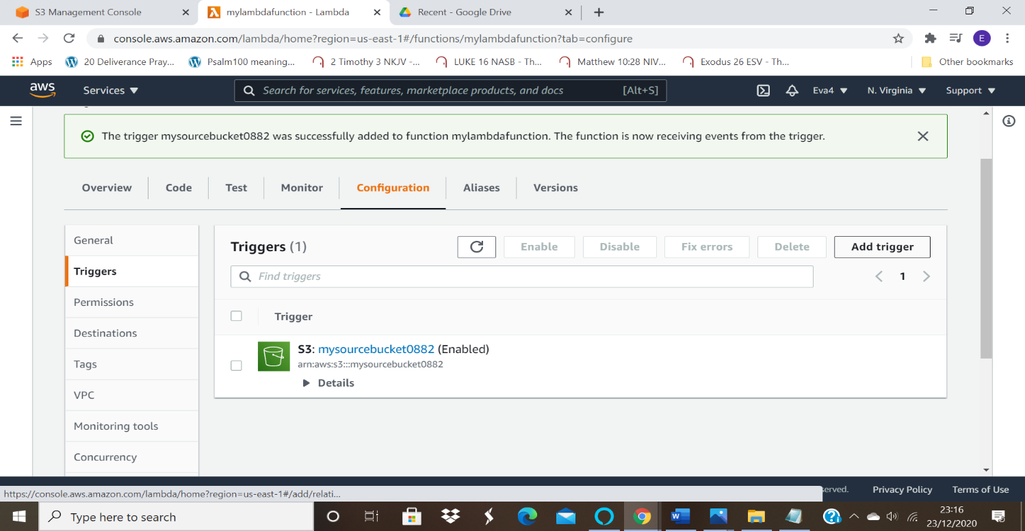
Step6: Test by uploading objects into the source bucket
ss9: Object uploaded in the source bucket
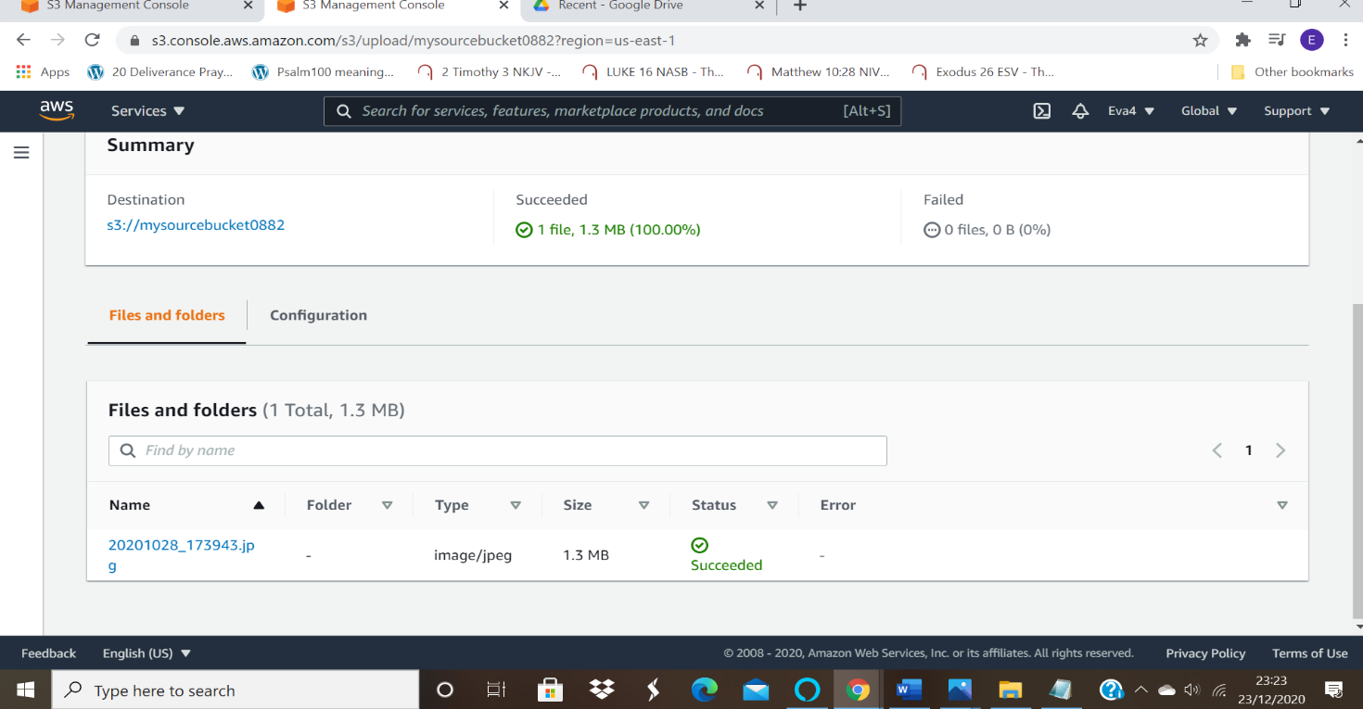
ss10: Object replicated in the destination bucket.
Object reflected in the destination bucket as below:
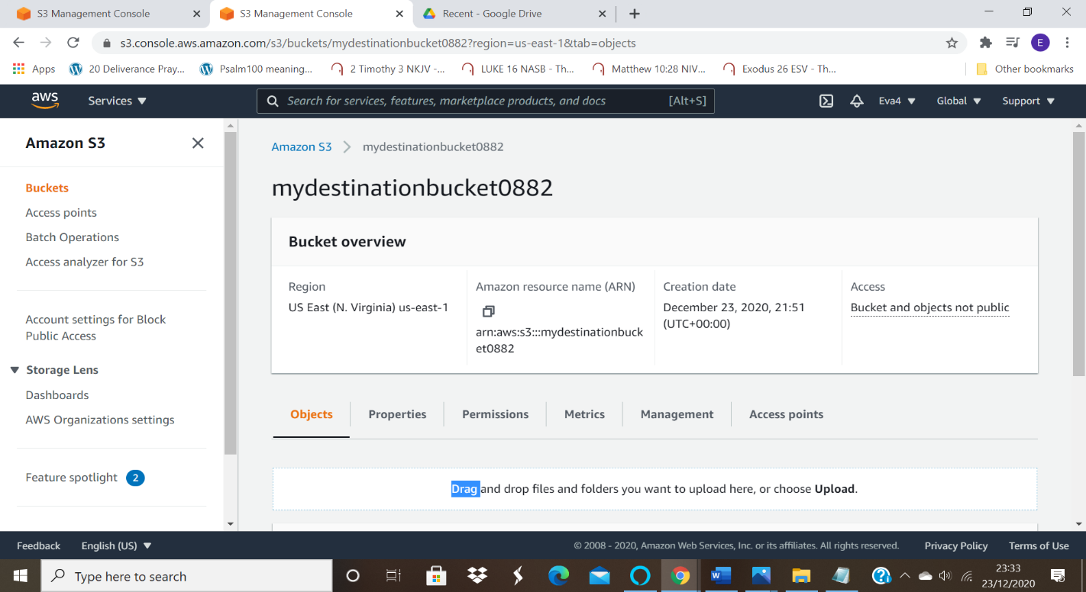

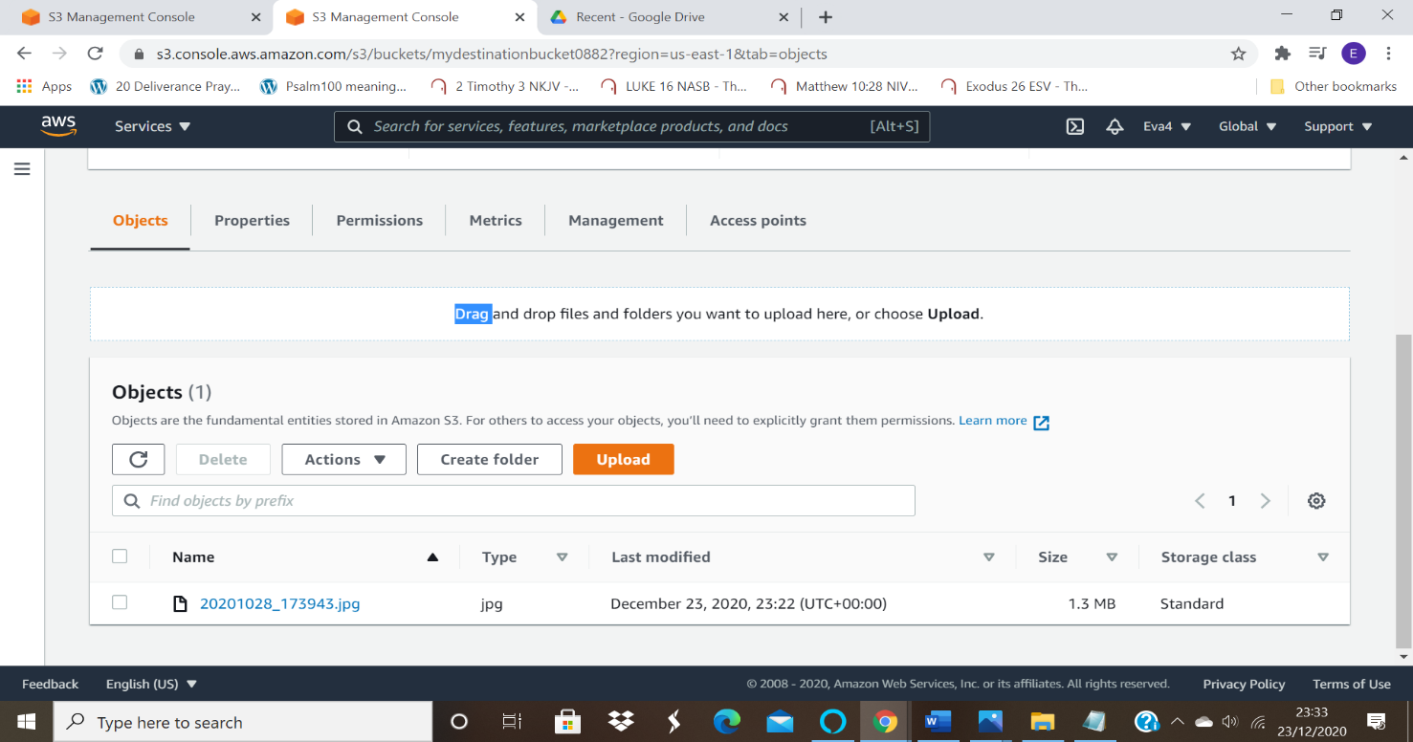

Question 2:
Working with Elastic container service using fargate
Step1: Getting started with amazon ECS using fargate
SS1: ECS console
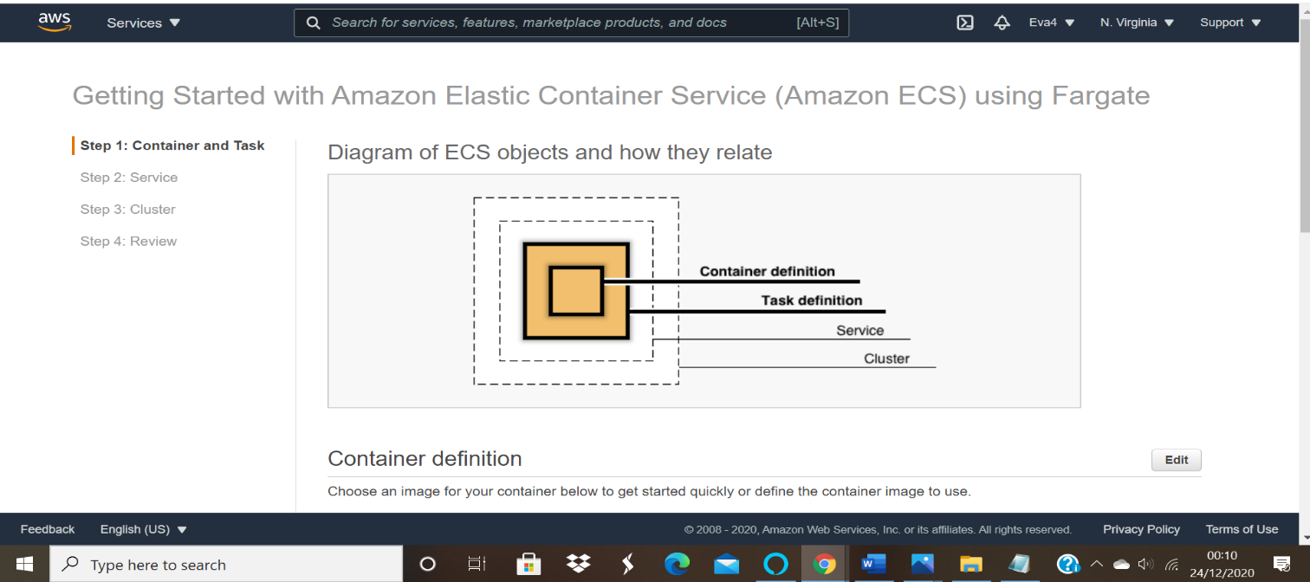
Step2: Creating container and task definition
SS2: 2nd panel with all options visible:

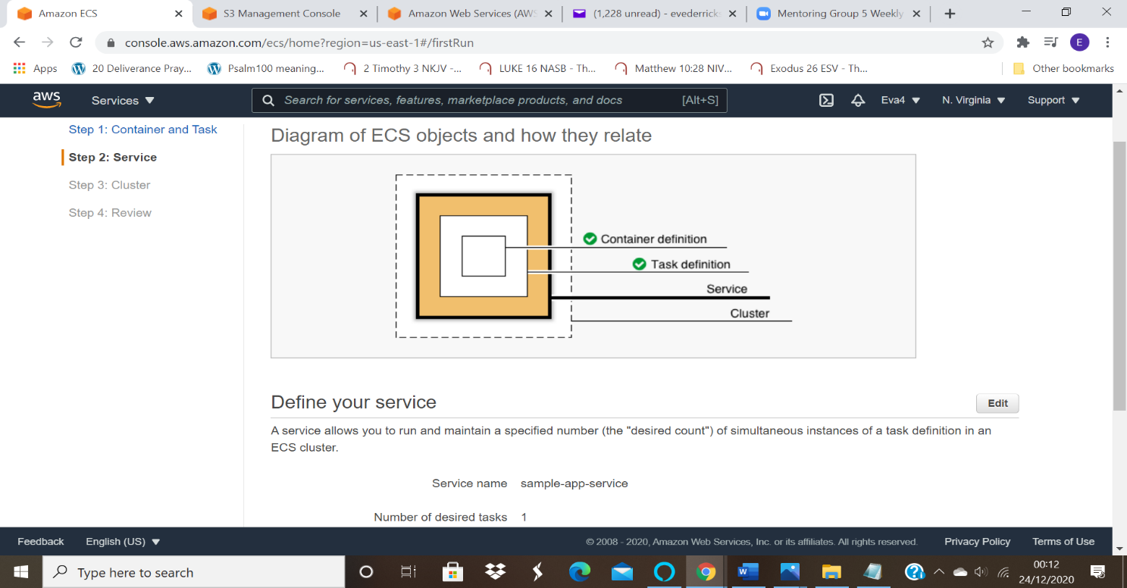

Step3: Configuring the service
ss3: Next panel
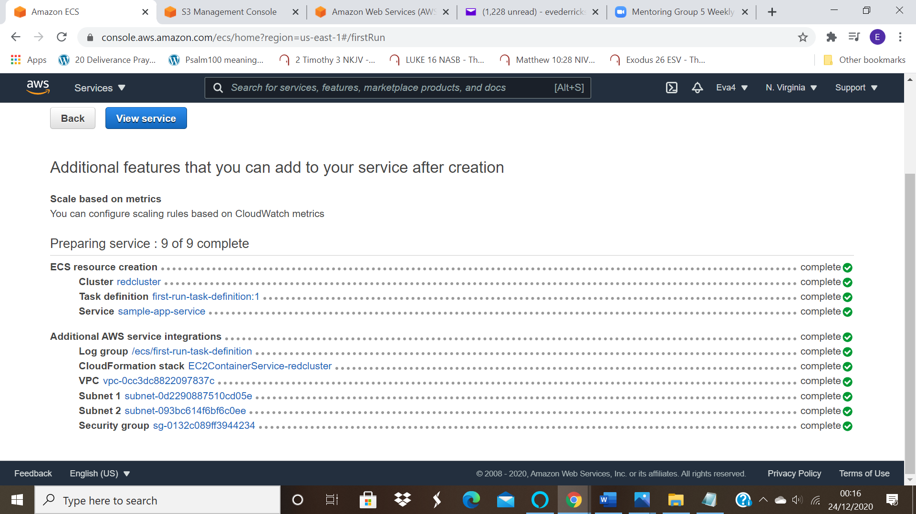
Step4: Configuring the cluster
ss4: Next panel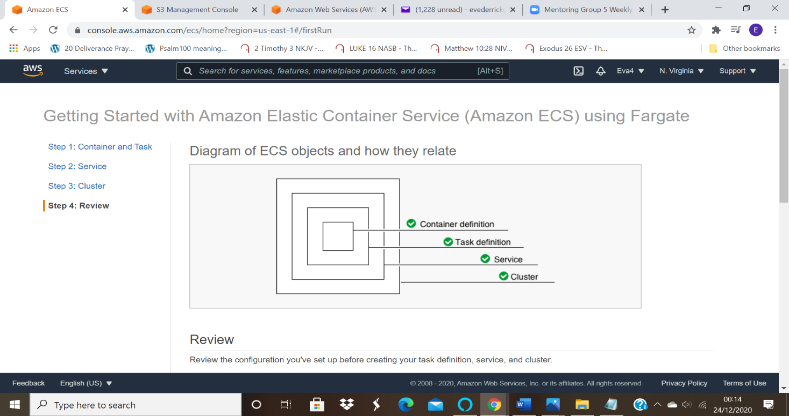

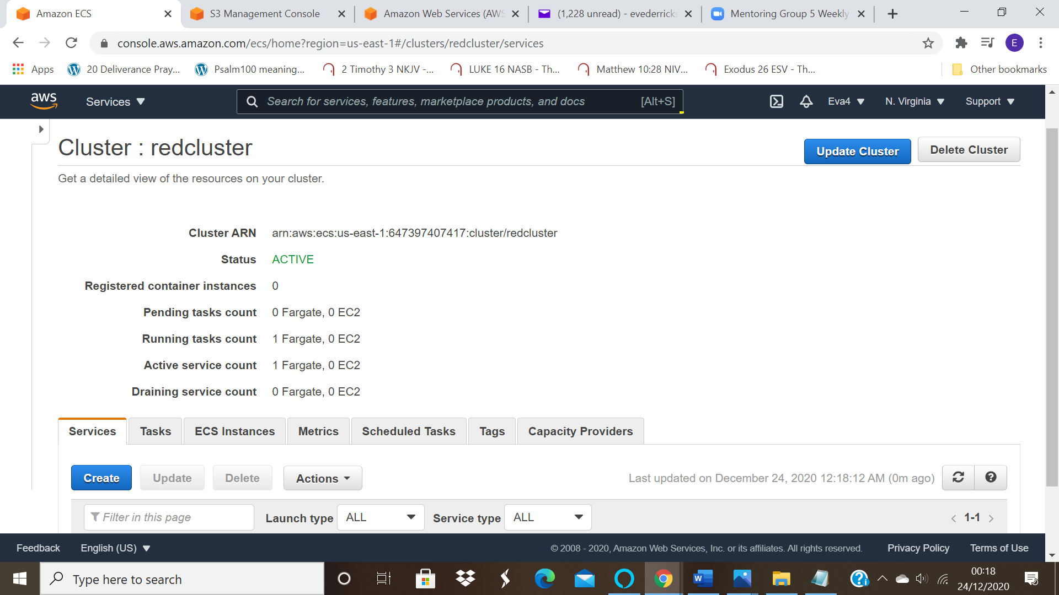

Step5: Viewing the service
ss5: Dashboard displaying the cluster created
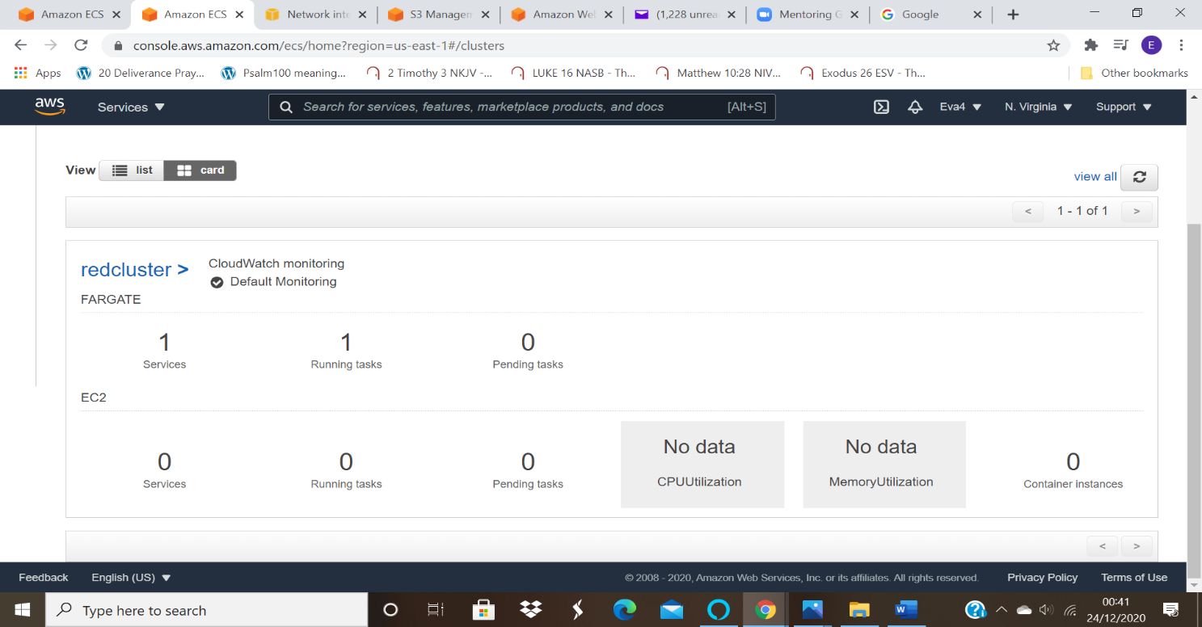
Sample Application:
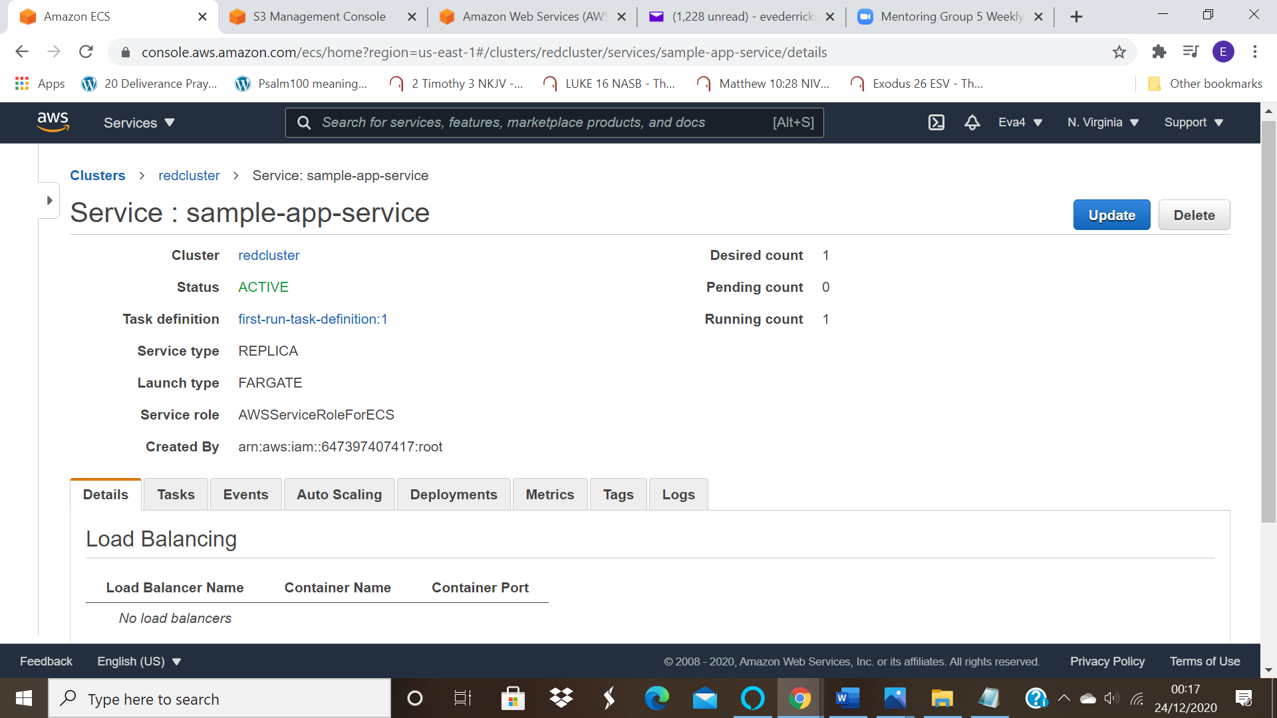

ss6: Cluster information

ss7: Panel displaying ENI ID
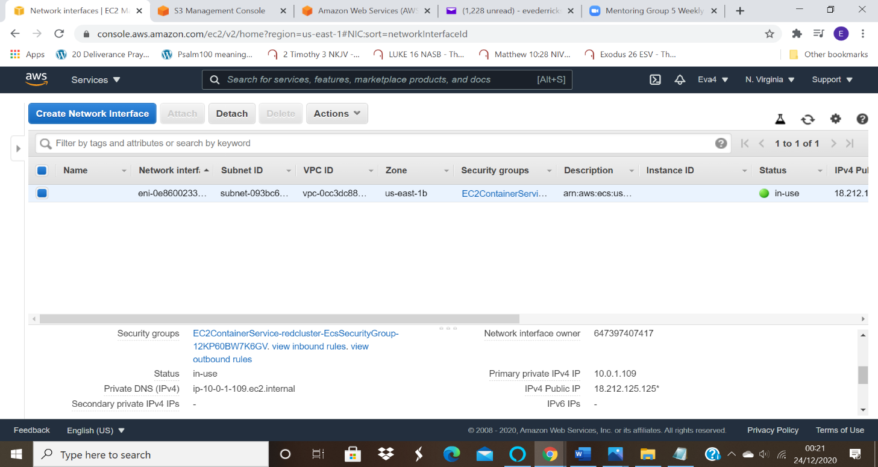

ss8: Panel displaying the private, public, and the macid
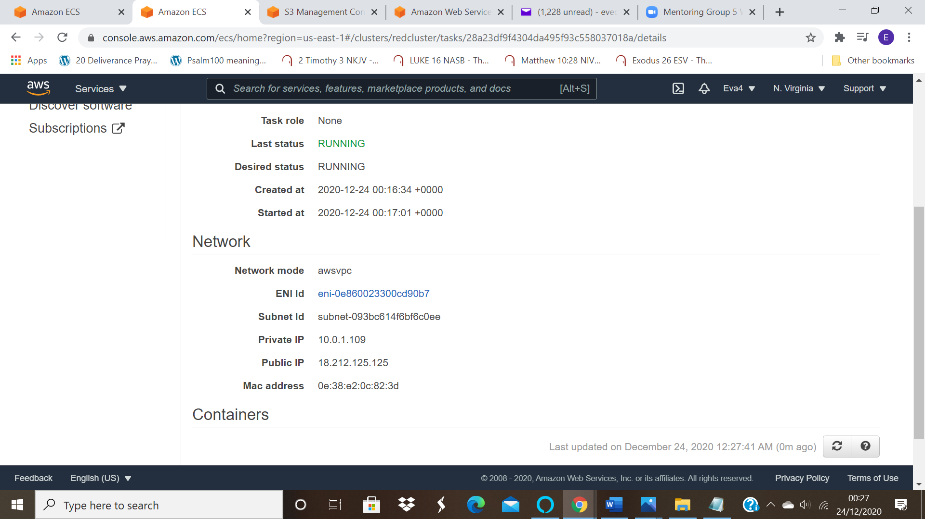

ss9: Display application
To get the application ;copy the public IP before address to the browser and get the page as shown on the picture.



